**Requirements and Design Document**

**Making Friends**

**1. Motivation**

In the world of Today, Facebook is more concerned with placing ads and fake news in news feed rather than helping people make friends. In addition, most of the social media apps are focused on hooking up with other people (via Tinder). We believe that a web application that is oriented on creating friendships should exist especially for people of UNCC campus.

**2. Scope and Objectives:**

The application we have proposed will have a number of features available to users. These features are outlined here.

* Have the website used by the faculty and students on the UNCC campus.
* Match individuals via common interests and hobbies.
* Employ a simple matching algorithm in order to match individuals.
* Have a feature to send and read messages to/from users.
* Feedback system that provides experiences given by users of the website.
* Create a “Report” button to cite inappropriate behavior.
* Allow users to search for individuals based on when they have free time so that the users can meet in person.
* Allow users to search for study partner/s to form study groups for their classes.

Provides feature where users can add events so that others can join them.

**3. Site Map**

Following is the site map for my application. It has 16 pages and functionality of each page is explained in detailed

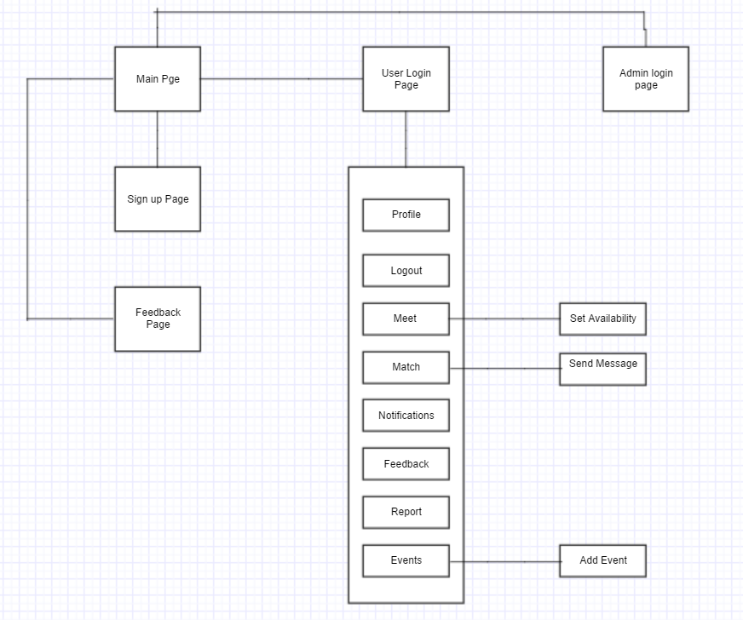

Main Page:

This page is the First page of application.

It has Login button and Sign up button

If the user is already signed up then he can login to the application or else he need to register.

User Login Page:

This page is used for login. It has two fields

Username

Password

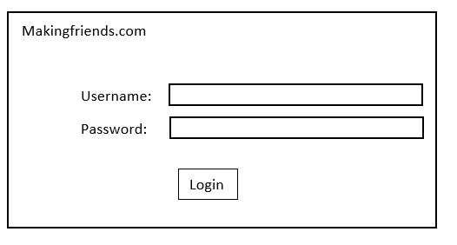

The user can enter to home page of application upon entering the correct details or else a alert message will be displayed saying “Wrong username or password”.

Admin Login Page:

This page is used for login. It has two fields

Username

Password

The user can enter to admin home page of application upon entering the correct details or else a alert message will be displayed saying “ Wrong username or password”.

Signup Page:

This page is used for signup of the user to the application.

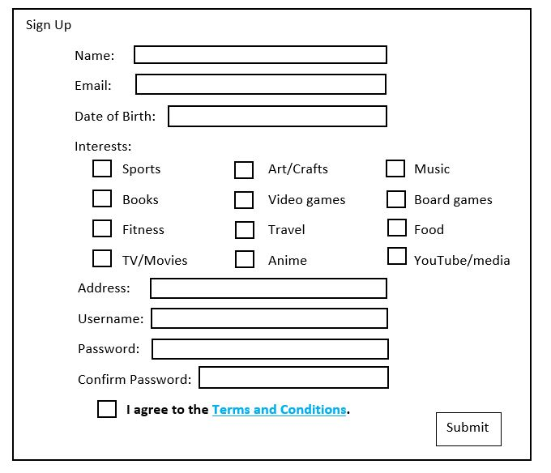

It has many fields which specifies the user details. Upon entering the correct details the user can register to the application.

Successful creation of user account by entering the required details on sign up page

Given :

1. User is on the Signup page

2. User has thought of username which is not already used

When :

User enters name as “Santhu”,

Email as speesu@uncc.edu,

DOB as “08/05/1994”,

Interests selected as Music, Food, Travel

Address as “9312 Kittansett dr” ,

Username as “shanmukhi”,

Password as “Xyz@123”,

Confirm Password as “Xyz@123”,

Selects the check box Agree to T&C

And clicks on Submit button.

Then

a) Popup indicating that “Account has been created successfully” is displayed to user.

b) User information is stored in the database on successful account creation.

A user wants to create an account . The desired username as intended by new user is already in use.

Given : 1.New user is on the signup page

3. Database having account with username “shanmukhi”

When : User enters name as “sai”

Email as xyz@uncc.edu,

DOB as “08/05/1994”,

Interests selected as Books,Sports

Address as “Unc Charlotte” ,

Username as “Santhosh”,

Password as “root@123”,

Confirm Password as “root@123”,

Selects the check box Agree to T&C

And clicks on Submit button.

Then : a. Popup saying that username is already in use is displayed to the user.

b. Database not changed

Invalid entries – user enters incorrect details such as invalid email id, not following password characters’ standard, and password mismatch.

Invalid email address

Given: The user is on signup page.

When: User enters email address as “xyz!123.com”

Then: Popup saying that “Invalid email address” is displayed to the user.

Password criteria not met-

Given: The user is on Signup page.

When: User enters password as “root123”

Then: Popup saying that “Password does not meet the desired specifications” is displayed to the user.

Password mismatch-

Given: The user is on Sign Up page

When: User enters

password as “paSSword@789”,

confirm password as “p@SSword@789”

Then: Popup saying that “Passwords do not match” is displayed to the user.

User enters all the details but does not agree to T&C conditions

Given : User is on the sign up page

When : User enters all the details as per standards and does not check agree to conditions and clicks submit button.

Then : Popup saying that “Please agree to T&C conditions and signup “ is displayed to user

Database is not changed.

User does not enter all the details on the signup page

Given : User is on the sign up page

When : User enters all the details except DOB and clicks submit button

Then : Popup saying that “DOB is missing” is displayed to user

Database is not changed.

Feedback Page:

In this page one can find the Average feedback of the application and individual feedback of each user.

It has a back button. Upon clicking this button user can go to main page of the application.

Profile Page:

Once the user enters into the home page of the application, he can find the profile button.

On clicking that button, user can enter into profile page.

Here all the information about the user is retrieved from the database and displayed in respective fields. When user hits the edit button, he can edit his details. Upon clicking the submit button, he can update his information in database.

This page has a home button. The functionality of this button is to revert back to home page of the application.

Logout Button:

When the user hits this button, he logs out the application and the main page of the application is displayed.

Meet Page:

Once the user enters into the home page of the application, he can find the Meet button.

On clicking that button, user can enter into meet page. In this page user has option to set his availability and he can search for people who are available during his availability time.

This page has a home button. The functionality of this button is to revert back to home page of the application.

As a user,I should be able to search for people available so that I can meet.

User navigates to meet page

**Given** : User is logged in and present on home page.

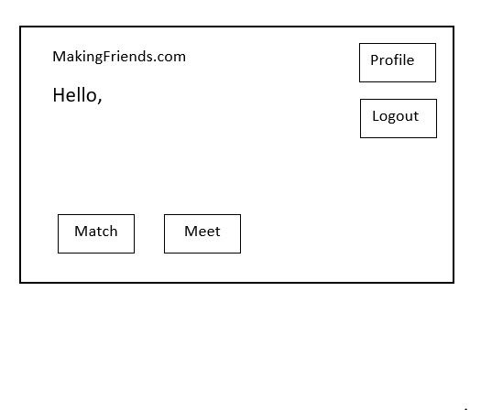

**When** : User clicks on Meet button

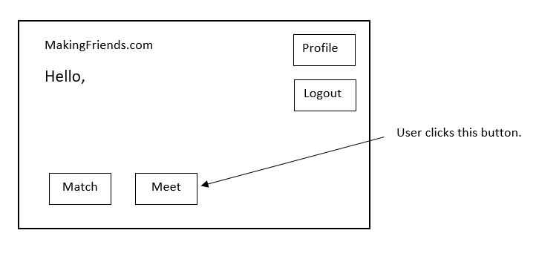

**Then** : User is redirected to the meet page.

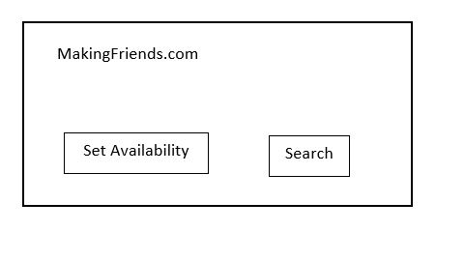

User navigates to settime page

**Given:**  User is on the meet page.



**When :** User clicks “Set Availability”

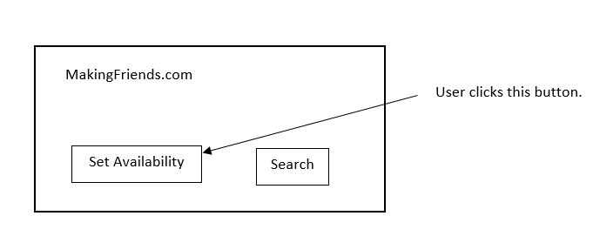

**Then :** User is redirected to next page “settime”.

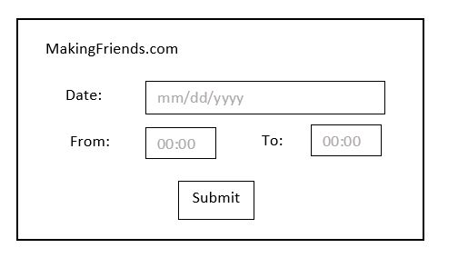

User sets the available free time

**Given :** User is on the settime page



**When :** User enters date and available time and clicks submit

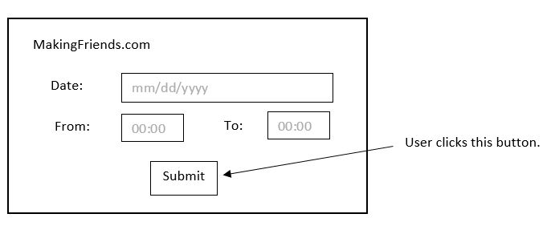

**Then :** information is stored in database and user is redirected to meet page.



User searches for Available persons(Successful Search)

**Given :** User is on the meet page



**When :** User selects the search button

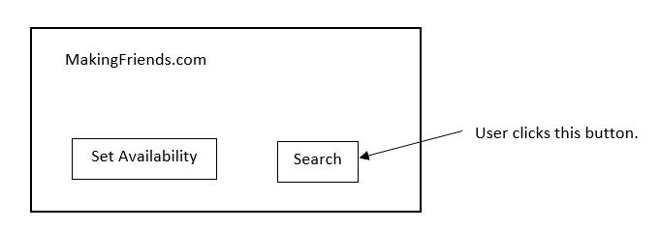

**Then :** User is displayed with person who has same available free time.

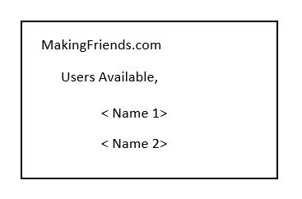

User searches for Available persons(Unsuccessful search)

**Given :** User is on the meet page



**When :** User selects search button and there are no persons who has same free time availability



**Then :** User is informed that “No persons available”.

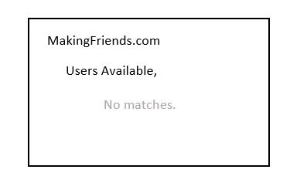

Match Page:

Once the user enters into the home page of the application, he can find the Match button.

On clicking that button, user can enter into Match page.

Here User can see the people who matches to his interests. This page has a send message button. This button is used to send message to the user.

This page has a home button. The functionality of this button is to revert back to home page of the application.

As a user,I should have match option so that i can find people with similar interests.

User searches for matching person and there are successful searches

**Given** : User ”Santhosh “ is logged in and present on home page and database has following entries

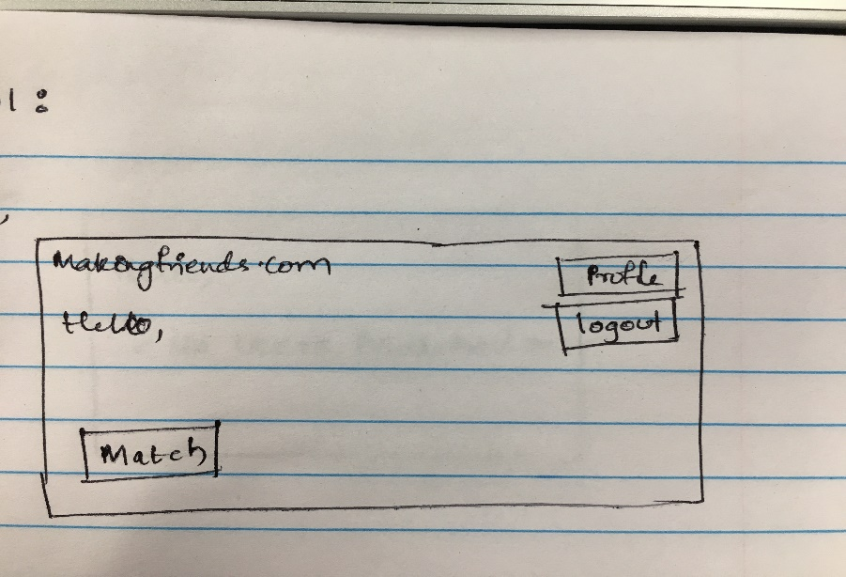

|  |  |  |  |  |  |  |
| --- | --- | --- | --- | --- | --- | --- |
| **Username** | **name** | **email** | **dob** | **interests** | **address** | **password** |
| Santhosh | Santhosh | speesu@uncc.edu | 10/05/1994 | Sports,animation | 9303 kittansett dr | santhu@1234 |
| pratyusha | prats | bbharata@uncc.edu | 10/22/1993 | Travel,Books,fitness | Ashford green | prats@123 |
| white | whitw | lwhite@uncc.edu | 03/24/1995 | Sports,music | Concord | Pqr#456 |

**When** : User clicks on Match button

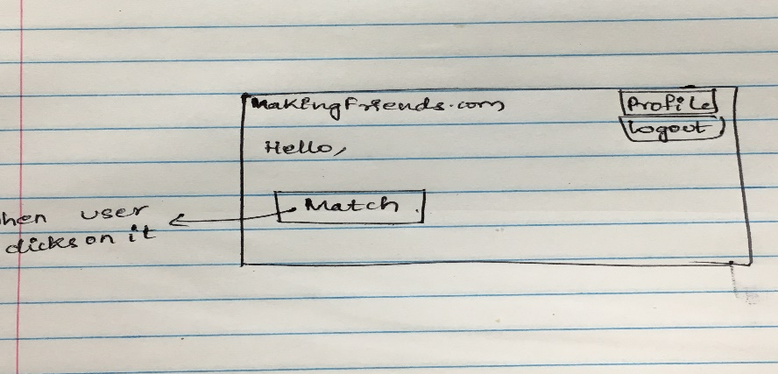

**Then** : User is displayed with list of matching persons in the matching page.

Ex: here it is lwhite.

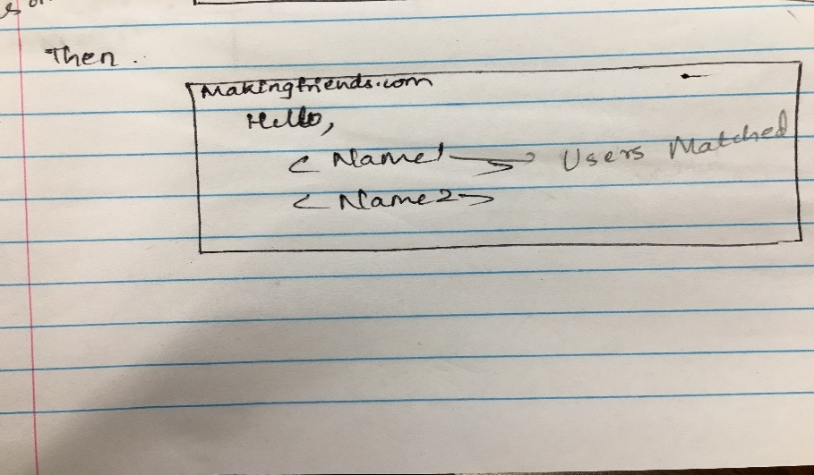

User searches for matching person and there are no results

**Given:**  User ”Pratyusha “ is logged in and present on home page and database has following entries



|  |  |  |  |  |  |  |
| --- | --- | --- | --- | --- | --- | --- |
| **Username** | **name** | **email** | **dob** | **interests** | **address** | **password** |
| Santhosh | Santhosh | speesu@uncc.edu | 10/05/1994 | Sports,animation | 9303 kittansett dr | santhu@1234 |
| pratyusha | prats | bbharata@uncc.edu | 10/22/1993 | Travel,Books,fitness | Ashford green | prats@123 |
| white | whitw | lwhite@uncc.edu | 03/24/1995 | Sports,music | Concord | Pqr#456 |

**When**: User clicks on Match Button



**Then** : User is informed that there are no matching persons.

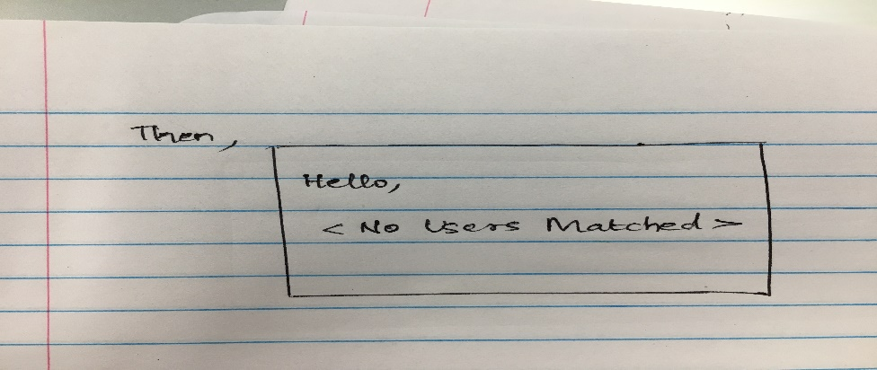

Notification Page:

Once the user enters into the home page of the application, he can find the Notification button.

On clicking that button, user can enter into Notification page.

Here user can find his notifications.

This page has a home button. The functionality of this button is to revert back to home page of the application.

As a user, i should be able to receive notifications so that i can be notified that other users matched with me or they requested to meet me.

User has at notification(s) in account

**Given :** User has already logged on to the home page

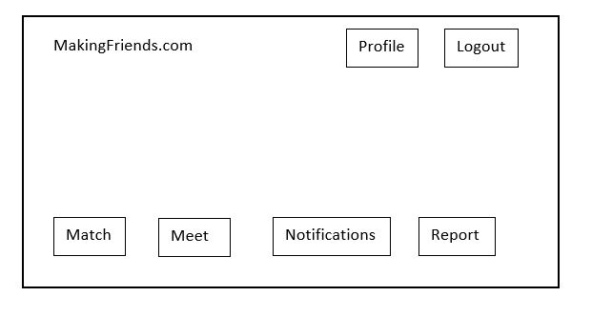

**When:** User clicks on the button “Notifications” button

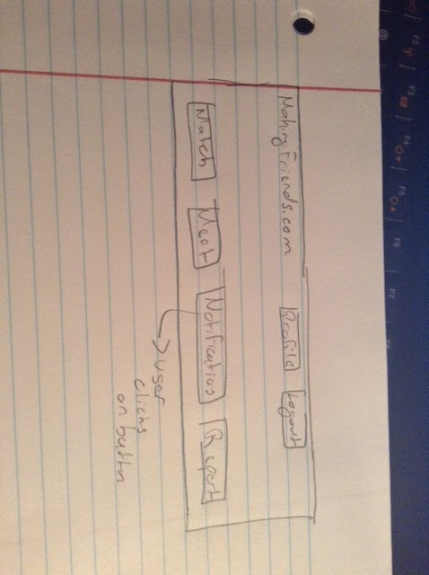

**Then:** User sees notifications in the notifications page

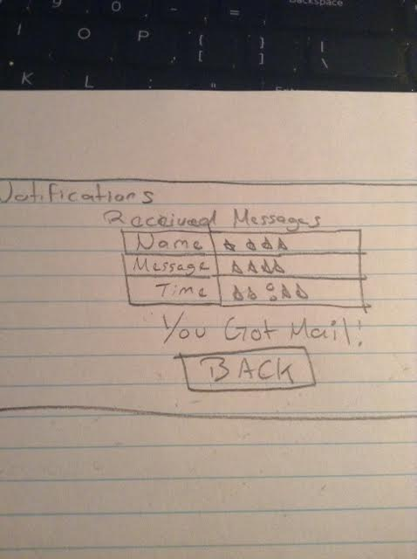

User does not have any notification in account

**Given :** User is already logged on to the home page



**When:** User clicks on the button “Notifications”



**Then:** User sees no notifications on the notification page

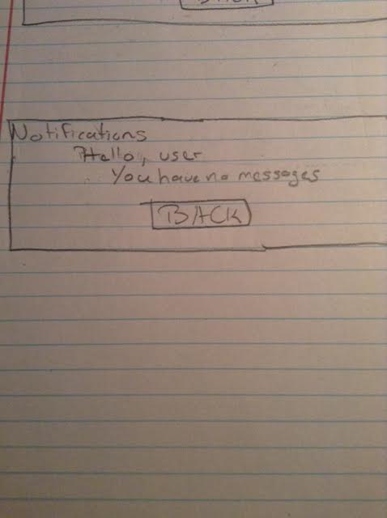

User wishes to go back to the home page after checking for notifications

**Given:** user has already logged on to the account and is at the Notifications page



**When:** User clicks on “Back” button

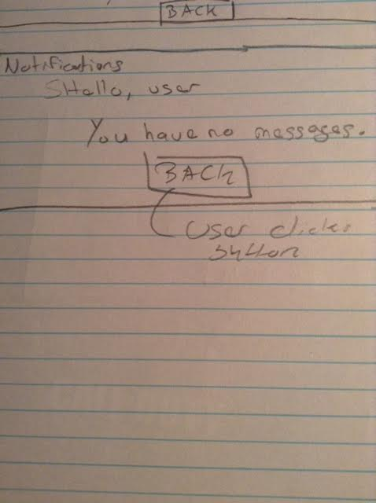

**Then:** User is redirected back to the home page



Feedback Page:

Once the user enters into the home page of the application, he can find the Feedback button.

On clicking that button, user can enter into Feedback page. Here he can give feedback and comment on application.

This page has a home button. The functionality of this button is to revert back to home page of the application.

As a user, I should be able to provide and view feedback so that feedback helps in making decisions of making friends.

User navigated to provide_feedback page

**Given** : User is logged in and present on home page

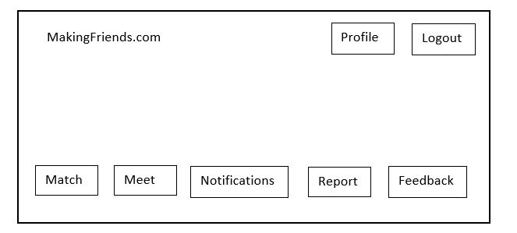

**When** : User clicks on feedback button

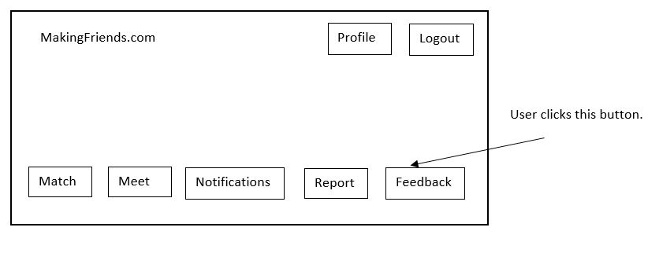

**Then** : User is redirected to provide_feedback page

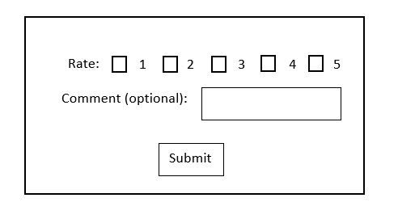

User submits feedback successfully

**Given:**  User is on the provide_feedback page



**When :** User enters feedback and clicks submit button

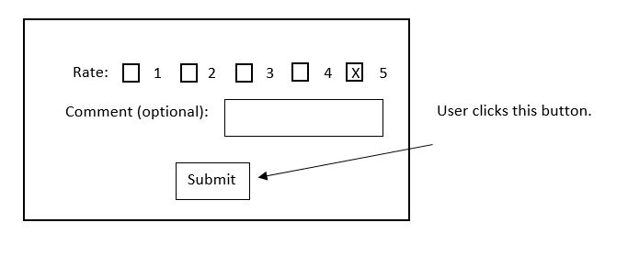

**Then :** Information is stored in feedback table and redirected to home page



User submits feedback unsuccessfully

**Given:**  User is on the provide_feedback page



**When :** User doesn’t enter feedback and clicks submit button

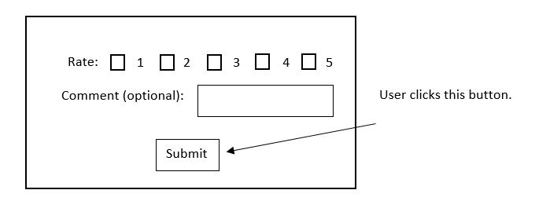

**Then :** Information is not stored in feedback table and user is prompted with no rating inputted

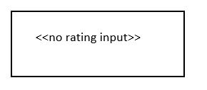

User views the feedback

**Given:**  User is not logged in and present on index page of website

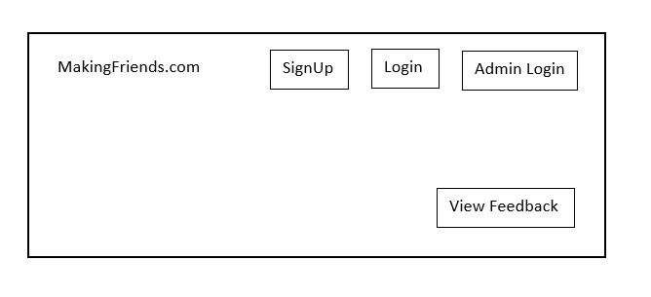

**When :** User clicks the view feedback button

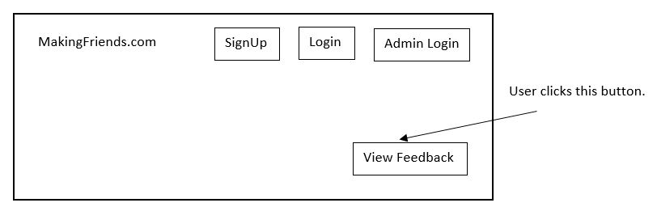

**Then :** User is redirected to the view_feedback page and displays the feedback.

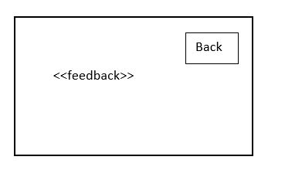

User wishes to go back to the home page after checking feedback

**Given:** user has already navigated to the view_feedback page



**When:** User clicks on “Back” button

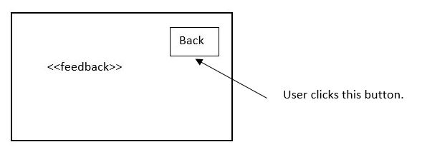

**Then:** User is redirected back to the index page of website



Report Page:

Once the user enters into the home page of the application, he can find the Report button.

On clicking that button, user can enter into Report page.

In this page user can find all other users and he can repost about his behavior to the admin.

This page has a home button. The functionality of this button is to revert back to home page of the application.

: As a user,I should be able to report the behavior of others so that others can view and be safe.

User navigates to report page

**Given** : User is logged in and present on home page



**When** : User clicks on Report button

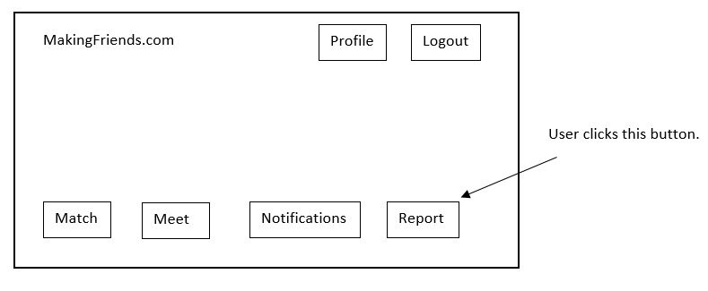

**Then** : User is redirected to the report page

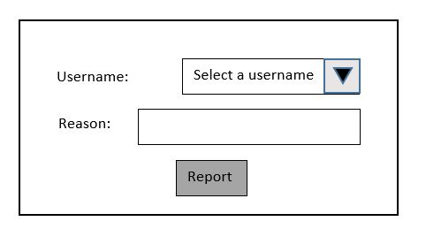

User reports the person successfully

**Given:**  User is on the report page



**When :** User selects user ,enters reasons and clicks report button

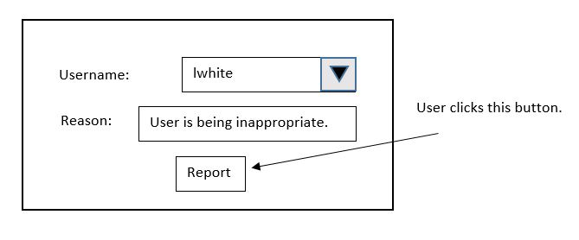

**Then :** Information is stored in report table and User is redirected to home page



Unsuccessful when reporting the person

**Given:**  User is on the report page



**When :** User does not select either username or enters reason



**Then :** Report button will not be enabled(button in disabled state)



Event Page:

Once the user enters into the home page of the application, he can find the Event button.

On clicking that button, user can enter into Event page.

User can find all the events and he can add an event up on click of add event button.

This page has a home button. The functionality of this button is to revert back to home page of the application.

As a user, I should be able to add events so that everyone can view.

User navigated to events page

**Given** : User is logged in and present on home page

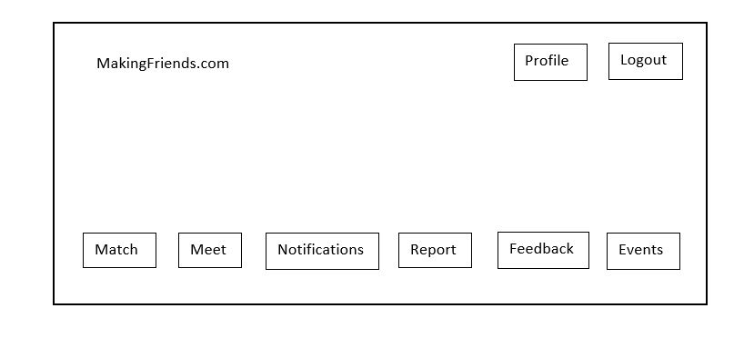

**When** : User clicks on events button

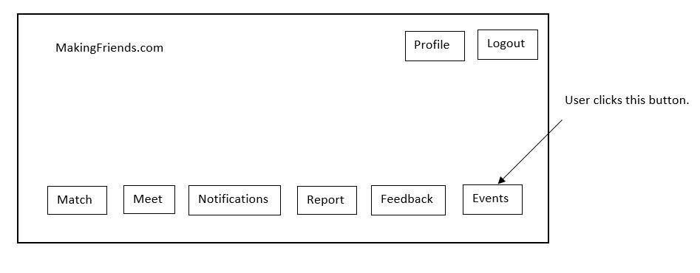

**Then** : User is redirected to events page

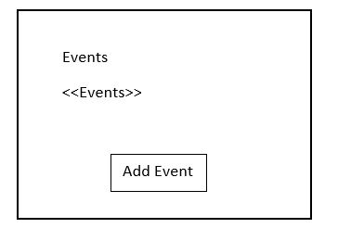

User navigated to add_event page

**Given:**  User is on the events page



**When :** User clicks on add button

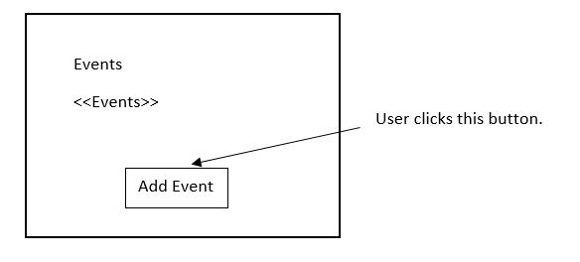

**Then :** User is redirected to add_event page

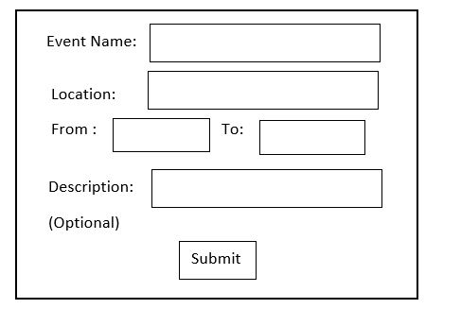

User adds event successfully

**Given:**  User is on the add_event page



**When :** User enters event name, time frame, location, description and clicks submit button

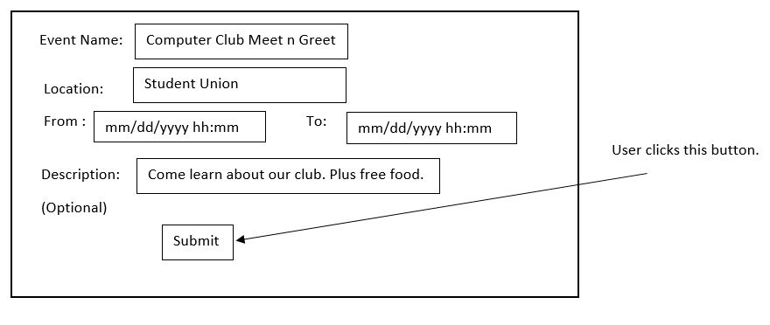

**Then :** Information is stored in event table and redirected to home page



User adds event successfully

**Given:**  User is on the add_event page



**When :** User enters event name, time frame, location, and no event description and clicks submit button

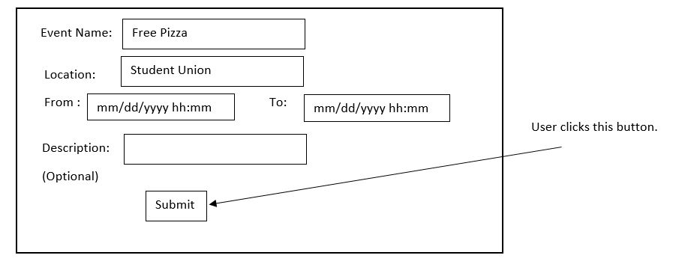

**Then :** Information is stored in event table and redirected to home page



User adds event unsuccessfully by having invalid or no name

**Given:**  User is on the add_event page



**When :** User enters invalid or no event name, and enters event time frame, description, location and clicks submit button

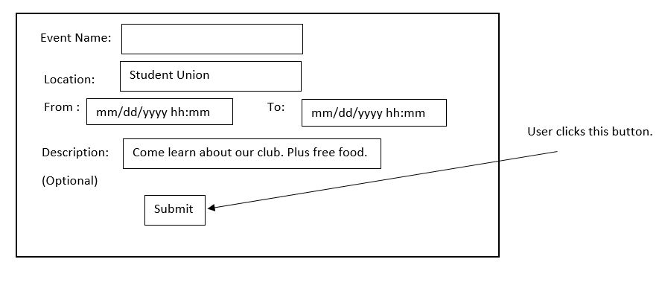

**Then :** Information is not stored in event table and user is prompted with invalid name input

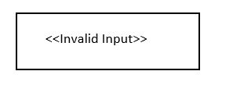

User adds event unsuccessfully by having invalid or no time frame

**Given:**  User is on the add_event page



**When :** User enters invalid or no event time frame, and enters event name, location, description and clicks submit button

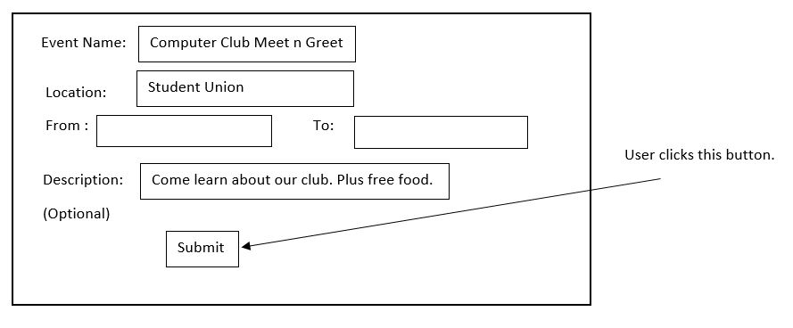

**Then :** Information is not stored in event table and user is prompted with invalid time frame input



User adds event unsuccessfully by having invalid or no location

**Given:**  User is on the add_event page



**When :** User enters invalid or no event location, and enters event name, time frame, description and clicks submit button

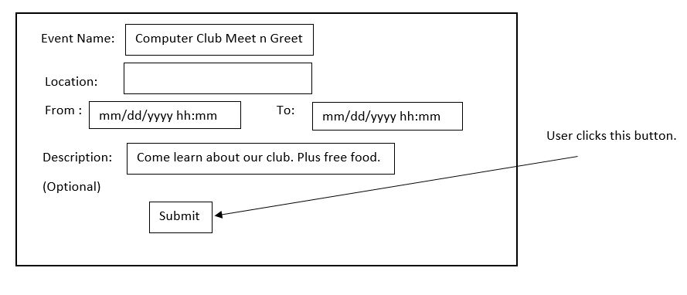

**Then :** Information is not stored in event table and user is prompted with invalid location input



ER Diagram :

